Business Performance Analytics & Sales Forecasting
- Power Bi
: PROJECT OVERVIEW
This project focuses on analyzing overall business performance using
key performance indicators (KPIs) and visual analytics.
The dashboard provides insights into sales, profit, quantity,
and includes a 15-day sales forecast to support decision-making.

: BUSINESS OBJECTIVES
• Monitor overall sales, profit, and quantity trends
• Identify top-performing regions, categories, and sub-categories
• Analyze customer segments and payment modes
• Compare monthly performance year-over-year
• Forecast future sales using historical data

: DATASET DESCRIPTION
• Sales transactions data
• Order Date, State, Category, Sub-Category
• Sales, Profit, Quantity
• Customer Segment
• Ship Mode and Payment Mode

: KEY KPIs
• Total Sales
• Total Profit
• Quantity Sold
• Average Delivery Days
• Monthly and Year-over-Year Growth

: DASHBOARD OVERVIEW (PAGE 1)
• Displays overall sales, profit, and quantity
• Segment-wise and category-wise sales analysis
• Monthly sales and profit trends
• Regional performance by state
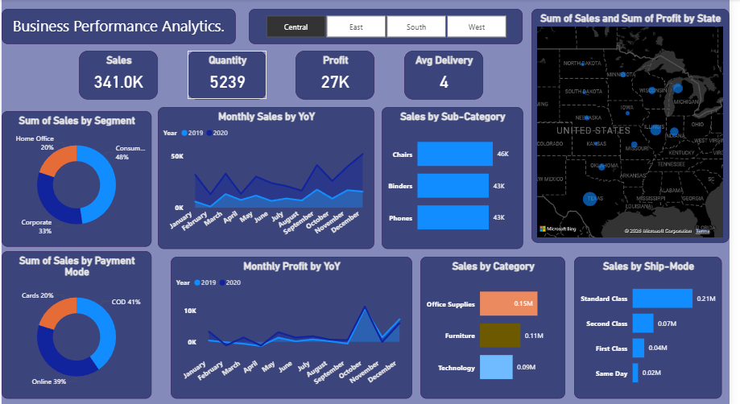

: SEGMENT & CATEGORY INSIGHTS
• Consumer segment contributes the highest sales
• Office Supplies category generates maximum revenue
• Furniture category shows lower profit margin
• Top sub-categories include Chairs, Binders, and Phones.

: SHIPPING & PAYMENT INSIGHTS
• Standard Class is the most preferred shipping mode
• Same Day delivery has the lowest usage
• Online and COD are the most used payment modes

: SALES FORECASTING – Sales Forecasting 15 days
• Forecast created using Power BI time-series forecasting
• Based on historical sales trends
• Predicts sales movement for next 15 days
• Supports inventory and sales planning
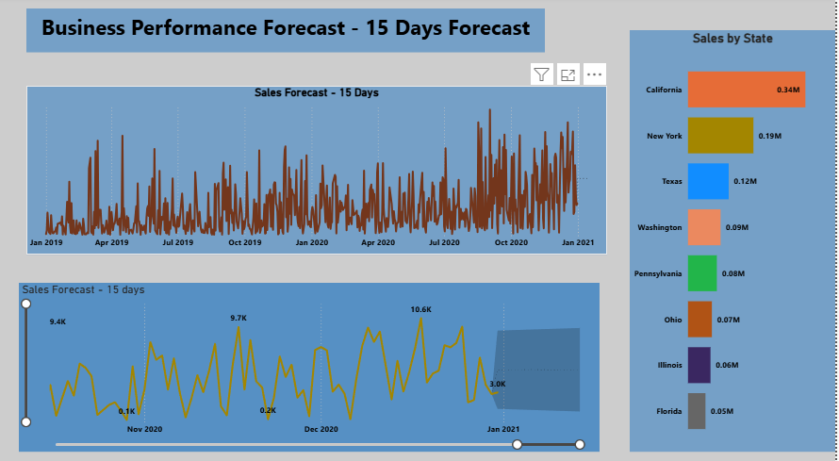
: FORECAST INSIGHTS
• Sales trend shows stable to increasing pattern
• Helps in demand forecasting
• Useful for short-term business planning

: TOOLS & SKILLS USED
• Power BI
• DAX
• Data Cleaning & Modeling
• Time Series Forecasting
• Business Analytics

: CONCLUSION
This project demonstrates how business data can be transformed
into meaningful insights and future predictions using Power BI.

